Codas are taking over the Disneyland Resort!!
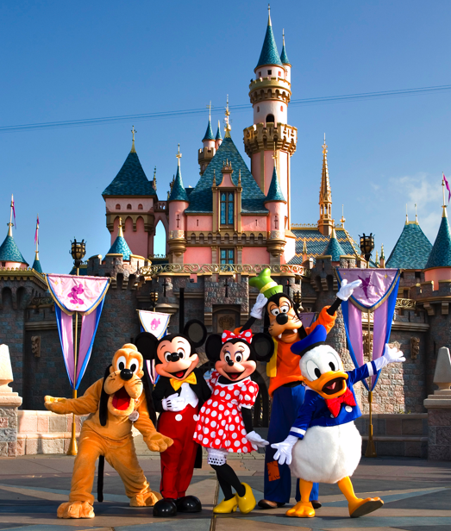
Join your fellow Region 5 peeps as we descend upon the Disneyland Resort for Laughs and Fun on October 13, 2016 from 8am-10pm.

Join us as we explore Disneyland Park and Disney California Adventure Park for the day as we try our best not to get thrown out of the park.

Friends, Family, and especially children of all ages are welcome to join in the fun!!

The cost for this event is will be $143.00
for a one-day Park Hopper Ticket.

Description of the Park Hopper Ticket:
Park Hopper® Ticket: The Park Hopper® Ticket include single-day admission with the opportunity to visit both theme parks on the same day, as many times as you like during park hours. Tickets are date-specific and will only be valid on the date noted below as the “Date of your Park visit".
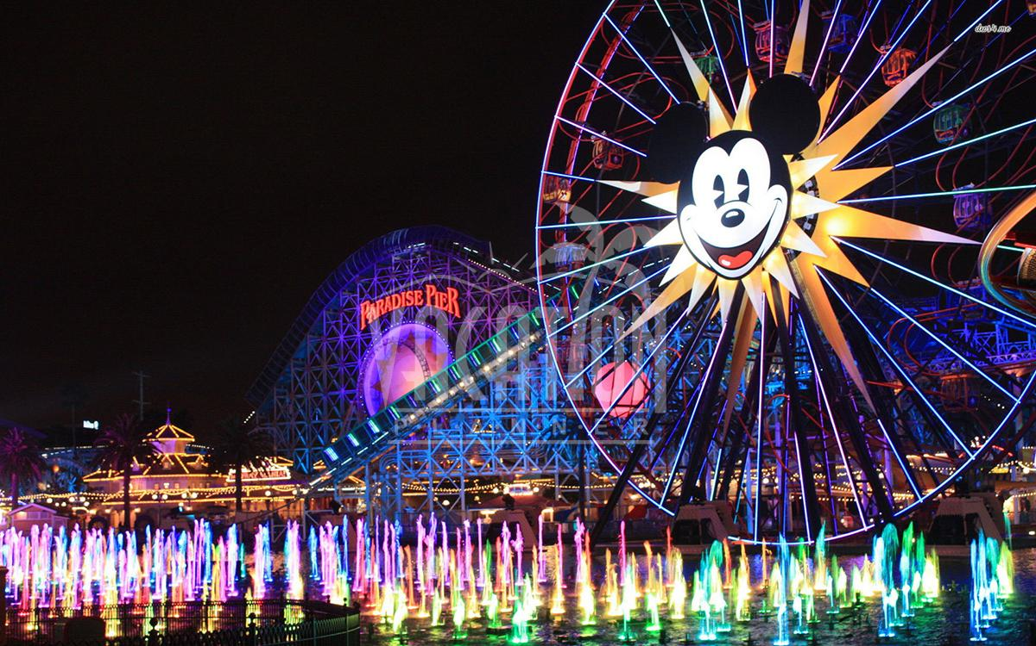
If your plans have changed and you are not able to visit on the date specified on the order, you can either mail your tickets back to get a refund or the amount paid for an unused, expired ticket may be applied towards the purchase of a new ticket at the retail price, so long as the new ticket purchase price is equal to or greater than the amount paid for the original ticket at any Disneyland Resort Main Entrance Ticket Booth, Theme Park Guest Relations location and Front Desk or Lobby Concierge at Disneyland Resort Hotels.
**This is a separate ticketed event from the Julian retreat. Lodging, food and transportation are not included in the ticket price. Join us by clicking the link below:
https://www.paypal.com/cgi-bin/webscr?cmd=_s-xclick&hosted_button_id=XHK5TSWMFXRZ

